https://www.cs.usfca.edu/~galles/visualization/Algorithms.html
https://visualgo.net/

Push 30,15,37,7,26,32,45,17,21,31,42
Push(30) : data pertama
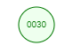

Push(15) : left : available
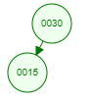
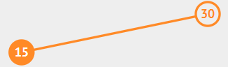
Push(37) : right : available
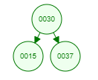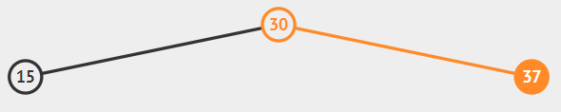
Push(7) : left : left ada node
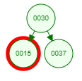
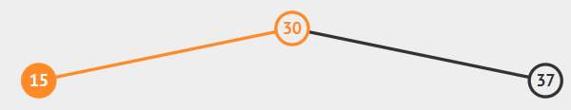
Left : available
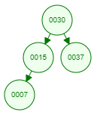
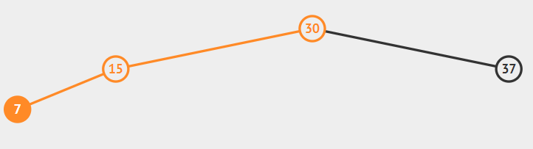

Push(26) : left : left ada node
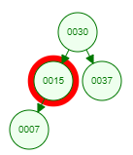
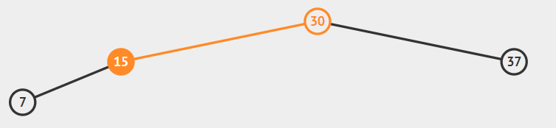

Right : available
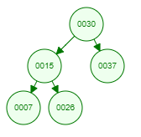
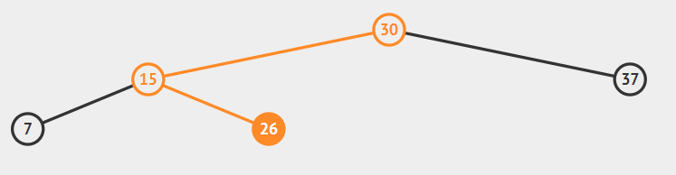

Push(32) : right-left
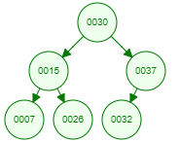
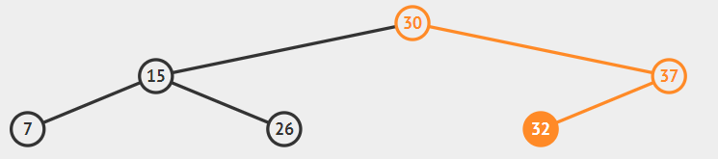

Push(45) : right-right

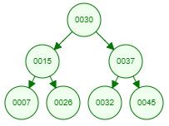
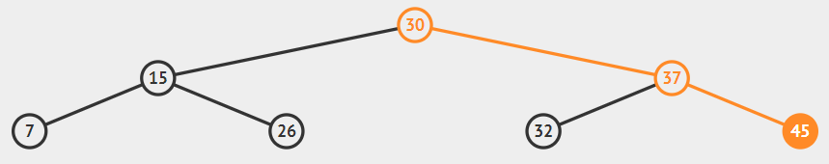

Push(17) : left-right-left
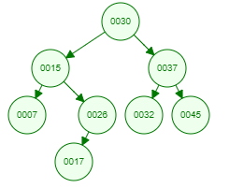
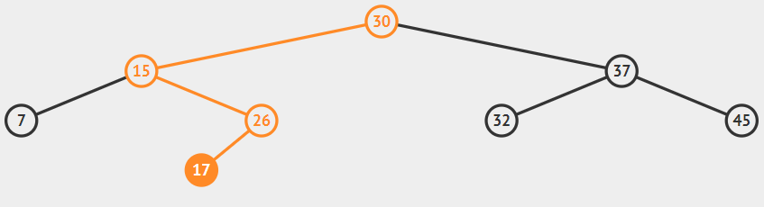

Push(21) : left-right-left-right

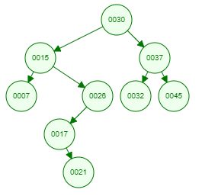
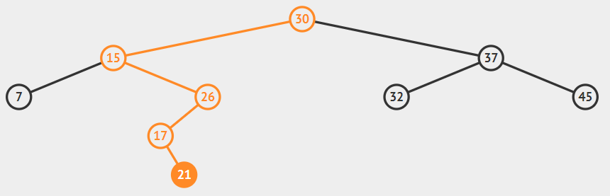

Push(31) : right-left-left
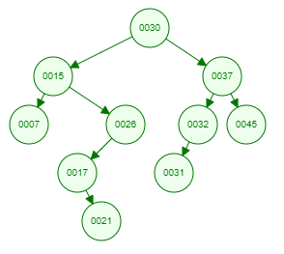
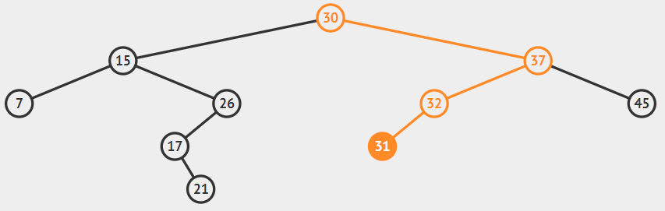

Push(42) : right-right-left
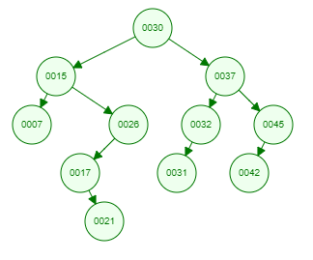
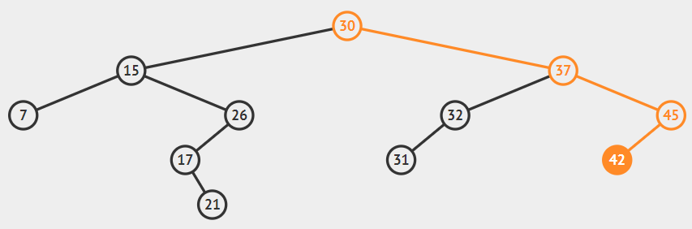
Pop 21, 37, 26

Pop(21) : leaf
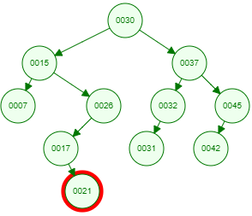 => 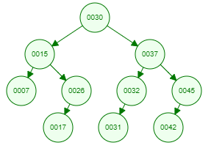
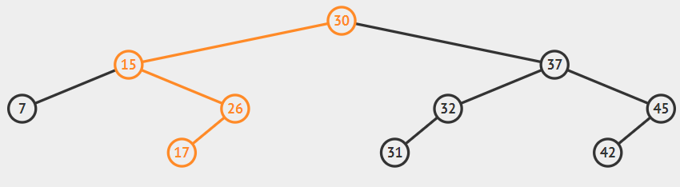

Pop(37) : 2 child
usfca : 2 child, replaced by rightmost data in left subtree (predecessor)
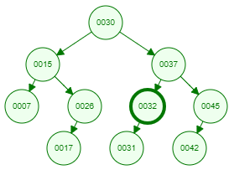=> 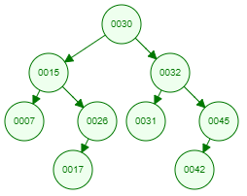

Visualgo : 2 child, replaced by leftmost data in right subtree (successor)
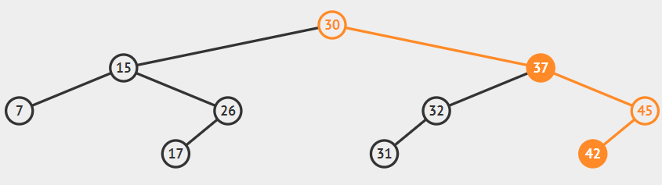
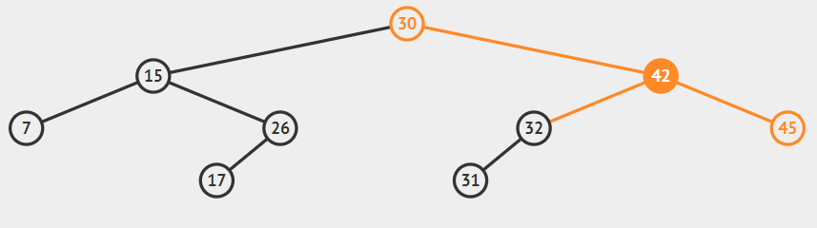

Pop(26) : 1 child
Usfca : replace by 1 child subtree
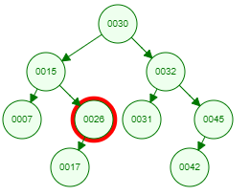=> 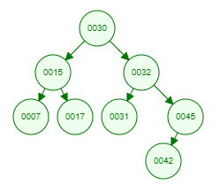
Visualgo : replace by 1 child subtree
